Experiment No:9
Date:

Experiment Title: Employee Management System
Aim:
The aim of this experiment is to design an Employee Management System to represent the flow of data between different modules such as Employee, HR Staff, Admin, Attendance, and Finance. The system helps in managing employee details, attendance, payroll, and reports efficiently. It reduces manual work and improves accuracy. The aim is to create a simple and clear system design for better understanding.

Problem Description:
In many organizations, employee data is managed manually, which is time-consuming and error-prone. It becomes difficult to track attendance and calculate salary correctly. There is a high chance of data loss and duplication. An automated system is needed to manage all employee-related activities. The Employee Management System helps in organizing and maintaining all data in a structured way.

Approach and Methodology:
The system is designed using a structured approach. First, the main modules such as Employee, HR Staff, Admin, Attendance, Finance, Report, and Database are identified. Then, the central system “Employee Management System” is placed at the centerAfter identifying modules, data flow between the system and modules is defined clearly. Each module is connected to the central system with proper labels. The design is kept simple and easy to understand. This approach ensures clarity and proper system structure.

Planning and Estimation:
The system is planned by dividing it into different modules for better management. Time is estimated for each stage such as analysis, design, and verification. Only essential data flows are included to avoid complexity.Effort is distributed among modules like attendance, payroll, and employee management. This planning helps in completing the design within the given time. It also ensures that all important functionalities are covered.

Scheduling and Design Considerations
The system design is scheduled in steps to maintain proper workflow. First, the central system is drawn, and then all modules are arranged around it. Arrows are used to represent data flow direction.Proper spacing and alignment are maintained to make the diagram clear and neat. Labels are added to indicate the type of data exchanged. The design focuses on simplicity, clarity, and easy understanding.
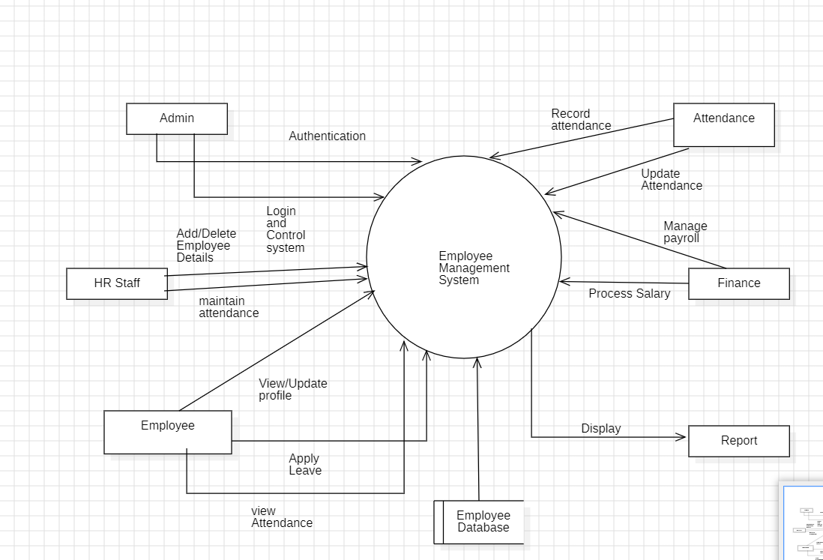

Feasibility Analysis:
- Technical Feasibility:
The system is easy to design using standard tools and concepts. It does not require complex technologies.
- Economic Feasibility:
The system reduces manual work and saves cost. No additional expense is required for basic implementation.
- Operational Feasibility:
The system is simple and user-friendly. Users like HR and employees can easily understand and use it.
- Schedule Feasibility:
The system can be designed and completed within the given time. It does not require extra time or resources.

Result:
The Employee Management System is successfully designed. The diagram clearly shows the interaction between different modules such as Employee, HR Staff, Admin, Attendance, and Finance. Proper data flow is represented between all components. The system structure is simple and easy to understand.
Conclusion:
This experiment shows that the Employee Management System can be effectively designed using a structured approach. It helps in understanding how data flows between different modules. The system reduces manual effort and improves efficiency. Overall, it highlights the importance of proper planning and design in software development.

